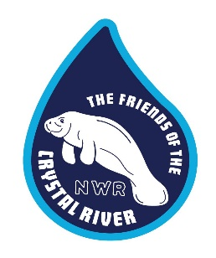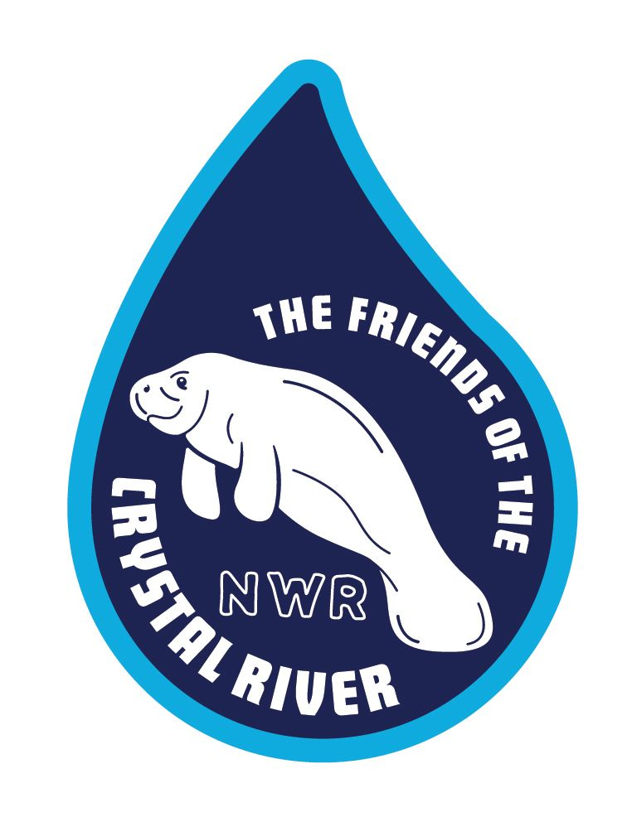

Level Paid: (Circle One)

Junior (5.00) Laughing Gull (20.00) Snowy Egret (50.00) Brown Pelican (100.00)

Bald Eagle (200.00) Whooping Crane ($500.00) Florida Manatee (1000.00)

# **Friends of the Crystal River National Wildlife Refuge Complex, Inc.**

## **Membership Application**

*The Friends of Crystal River NWR depend on our membership support to assist with providing funds for Refuge programs. Please use this application for new or renewing membership. You may also join* the *Friends of CRNWR on our website at:* [www.friendsofthecrystalriver.org](http://www.friendsofthecrystalriver.org) (*Get involved*)

**Please type or print and fill out all information requested below:**

**Name: ________________________________________ Date: / /**

**Address: ______________________________________**

**City: ________________________ State: ___________ Zip: _______________**

**Phone: _____________________ Email: ______________________________**

**New Member Renewal (Circle one)**

*The Friends of Crystal River NWR is a 501( c ) 3 non-profit organization and all donations are tax deductible. Consult your tax advisor for further information.*

***ANNUAL*** *Membership in the Friends of CRNWR includes member pin, newsletters, invitations to members only events and a 10% discount at the Friends Nature Store. Other benefits are applicable to different levels pf Friends CRNWR and may change periodically.* ***\*Memberships expire on the last day of the current year. Memberships purchased between 10-1 and 12-31 will expire on March 31 of the next year***

*The Friends Nature Store is located at 1502 SE Kings Bay Dr, Crystal River, Fl. 34429*

*352-563-2088*